STRUCTURE OF THE IRON OXIDE Fe_{x}O_{y} COMPLEXES WITH GLUCOSE AND DI−GLUCOSE
G.D.Abbasova, I.N.Alieva, N.M.Gojayev, M.A.Ramazanov, N.S.Nabiyev
Chair of Optics and Molecular Physics, Baku State University,Baku, Azerbaijan

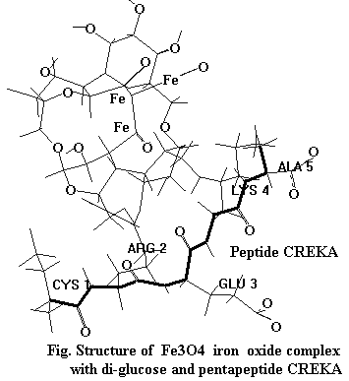
The prospects of modern diagnostic and clinical medicine are based on the use of nanoparticles that seek out tumors and bind to their blood vessels, and then attract more nanoparticles to the tumor target. Nanoparticles from superparamagnetic amino dextran-coated iron oxide (SPIO) are widely used in the clinic to enhance MRI imaging. In this report the spatial and electronic structure of the glucose and di-glucose, the dextran monomer units and their complexes with iron oxide Fe₃O₄ was investigated by molecular mechanics and quantum chemistry methods. Calculation models were constructed on the base of atoms coordinates in accordance with results of molecular mechanics calculations by the MM⁺ method. The main electronic parameters such as electron and nuclear energy, electron density distribution, electron and nuclear forces, total dipole moments and dipole moments of individual bonds in dependence of low-energy conformational state were analyzed according to result of PM3 semiempirical calculation method. The calculation results will be used for describing the attachment of tumor seeking peptide molecule CREKA to the dextran-coated iron oxide nanoparticles. In particular, SPIO's labeled with a set of different peptides with individual targeting might be of interest in the future. Calculation results give the following values of the geometrical parameters of the di-glucose complex with iron oxide Fe₃O₄ and CREKA molecule: (1) Fe=O and Fe-O bond lengths are 1.73Å and 1.89Å (instead of 1.48Å and 1.77Å for the free iron oxide Fe₃O₄); (2) Fe-C bond length is 1.99 Å; (3) Fe-O-Fe valence angle is 109.2⁰; (4) O=Fe-O angle is 118.1⁰.

